EX NO:09
DATE:
GLOBAL SUPERSTORE ADVANCED CHARTING
AIM: To create advanced charts in Tableau using the Global Superstore dataset, including Bar-in-Bar, Bullet, Barbell, Lollipop, and Bump charts to compare business performance and analyze sales, profit, and ranking trends.
Create the following chart: Using Global Superstore
- Bar in bar
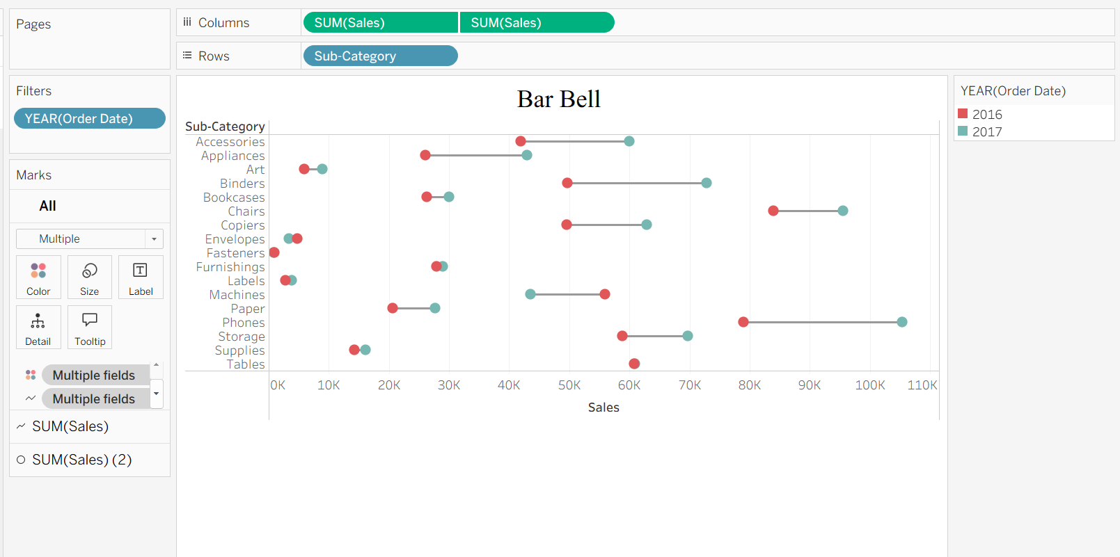
- Bullet
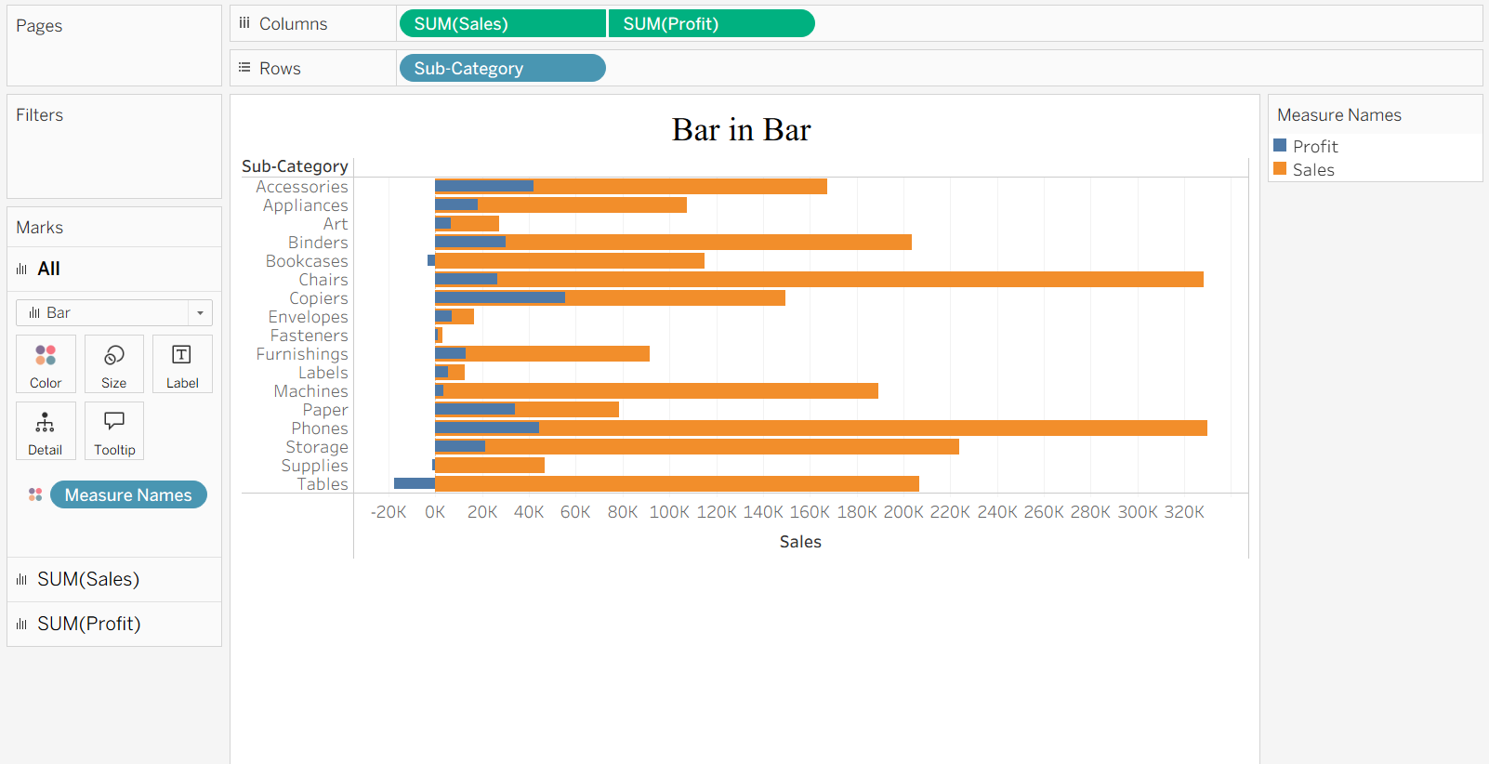

- Barbell
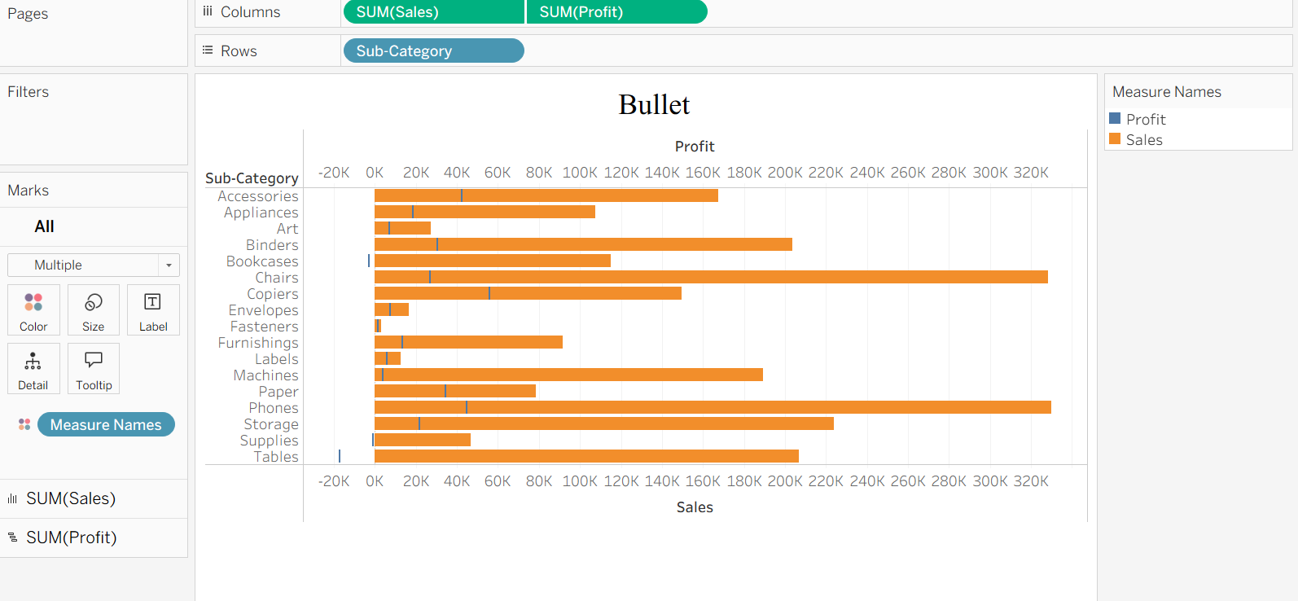
- Lollipop
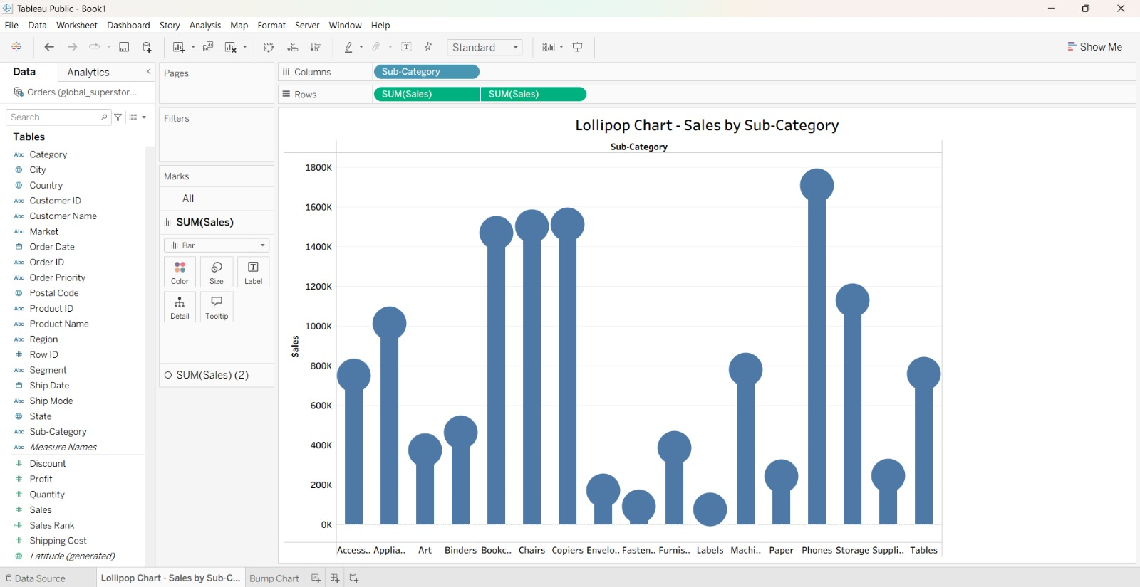
- Bump
